Fostering Creative Thinking in the Classroom
A+ Schools 20th Anniversary Conference
Sheila Kerrigan

Agenda
Silent Brainstorm
Introduction
Creating Safety
Check In
Guideline Setting
Preparing for Creative Thinking
Point and Say Wrong Words
Introductions, Reflect
Lying Introductions
Writing
Allowing for Creative Thinking
Rounds
Small Group Roles
Small Group Collaborations on 10-second seeds
Show Work
Making Critique Safe
Peer Critical Response
Check Out: Affirmations, Reflection

Creative Thinking
“Creative thinking deviates from ordinary modes and is sometimes at odds with standard rules and conventions. Creative people sometimes oppose and seriously criticize the dominant values of the society in which they live.…Anything moderately or radically new has, throughout all cultures and history, tended to produce an experience of discomfort and a pressure to resist it.”

Creative thinking starts with a need, a real purpose. Creative thinking produces anxiety. It is exhilarating and exhausting. The ultimate creative solution is rational; the process of getting to it is not.

Creative Thinking Techniques We Can Use and Teach
- use analogy and metaphor (poetry)
- identify with the problem (mime it)
- look for pleasurable mental excitement; it is a signal that you are on the right track
- tolerate and use the irrelevant (tangents are OK—they may lead you to your goal)
- play, giggle, joke—suspend disbelief in a childlike way (theater)
- make the familiar strange—distort, transpose, flip it, juxtapose it with something unrelated, look at it from many angles, take it apart and put it together differently, view it out of focus or in microscopic or telescopic focus, reverse solids and spaces, use fantasy (fiction), investigate wish fulfillment: what in our wildest dreams?
- make the strange familiar—analyze, investigate, explore, look at it in a new way
- use Janusian thinking—consider two contradictory ideas at the same time
- use homospatial thinking—imagine two entities occupying the same space
- play with words, meanings, definitions, sound-sense, rhyme, rhythm, puns (poetry)
- play with logical systems—change them
- state the commonplace, the partial, the tentative, the obvious, the wrong, the opposite, the vague sensation
- embrace non-rational thinking, incomplete thoughts, images
- Pay attention to and incorporate accidents, distractions, interruptions, irrelevancies, and errors
- Embrace paradox, opposition, antithesis, reversals, contraries, ambiguity, conflict.

Laura Milas, Art Department Chair, Hinsdale Central H.S., Illinois has some questions to spur creative thinking at the National Arts Education Association website: http://www.naea.typepad.com /naea/2011/04/index.html

About Brainstorming
Studies show that group brainstorming out loud does not produce the best ideas. A better way to brainstorm is called nominal group technique. Each person does a silent, written brainstorm—listing as many solutions to the problem or question as possible in a few minutes. Then they each read out their list and people scribe the ideas on a board—no editing, except for repeated ideas.

I like to get people’s ideas up on a wall where everyone can see them, and the ideas can talk to each other. We can move the ideas around. This way, the ideas speak for themselves. They do not carry with them the power of the person who thinks of them. This is one way to equalize the power differentials in the room.

Checking-in
Checking in means taking a moment to discover how you feel now and reporting on your feeling briefly to the group. It means listening openly and empathetically to everyone’s check-in. It means taking into account what people say about how they feel as you proceed with the work. You can check in about how you feel spiritually, emotionally, mentally, and/or physically.

Checking in helps bust the Northern-European-based bias against expressing emotions. Feelings are facts. They give us important information. Suppressing the expression of them is oppressive. It is also a good practice for performers to bring awareness to their feelings moment-to-moment. (I learned to check in from Marlene Johnson.)

Guideline-Setting Guide
What is guideline setting? Guideline setting offers group members a way to address how they want to do their work—it gives them a place to examine their group process and come to consensus about how they want to be with each other.

Why have guidelines? Not every group can articulate their guidelines, but every group has some, whether they voice them or not. Unwritten rules cause discord. Guidelines clarify your working process and eliminate secrets and hidden agendas. When everyone helps to compose guidelines, everyone assumes responsibility for sticking to them, and everyone has a stake in enforcing them.

How else is guideline-setting beneficial? The process of talking about what people in a group need is a way to bring into the light the cultural differences among members. People from different cultures have different expectations, and people (especially members of the culturally dominant group) tend to assume that our expectations are universally shared. The process of parsing out what different group members mean by “respect” can reveal diverse expectations. The process of crafting guidelines that work for everyone in the group can help members of a group understand each other and consciously provide what is needed for collaborative creativity.

How do you set guidelines?
- The facilitator describes the work the group will be doing and asks, “What behaviors from the people in this group do you need in order to do your best, most creative work?”
- Scribes write down what people say in the words of the speakers.
- If someone uses a generalism, like, “respect,” the facilitator asks, “What does respect look like and sound like to you?” Or, “How do you know when someone is respecting you?”
- When the group seems to be finished with the list, the facilitator reviews them to make sure everyone understands each one. Then the facilitator goes down the list one at a time and asks if everyone can agree to each suggested guideline. If one person (or more) says no, the guideline is crossed out and does not become part of the group norms. (But everyone knows it is important to someone in the group.)
- The facilitator says, “These are our guidelines, and we have agreed to abide by them. It is up to each of us to help us stick by them with friendly reminders when someone forgets.”
- The guidelines that everyone agrees to abide by get written up, posted, and everybody gets a copy.
- Guidelines can be revisited and revised as issues arise and should be revisited whenever someone new joins the group.

Rounds
(I learned rounds from Tony Montanaro at the Celebration Barn.)
Rounds are a way of brainstorming on your feet.
Rounds have a few rules:
- You agree on the topic of the round, or you do an open round—no topic.
- You take turns—go around the circle.
- When it is your turn, you get up and do a short, half-baked idea on the topic.
- Each person gets up when it is his/her turn—no passing. If you don’t have an idea of what to do, do something abstract or do what someone else has done in your own way. If you need more people to do your idea, you quickly grab people and tell them what to do and do it.
- When it is not your turn, you watch silently and take notes of what you like.
- You keep going around until the quality of the ideas peters out.
- When the rounds are over, you talk about what you saw that you liked, what it made you think of or reminded you of, and where it might go. (You do not talk about what you did, only what you saw. You do not say anything negative about anything anyone did. You do not question anybody about what they did.)
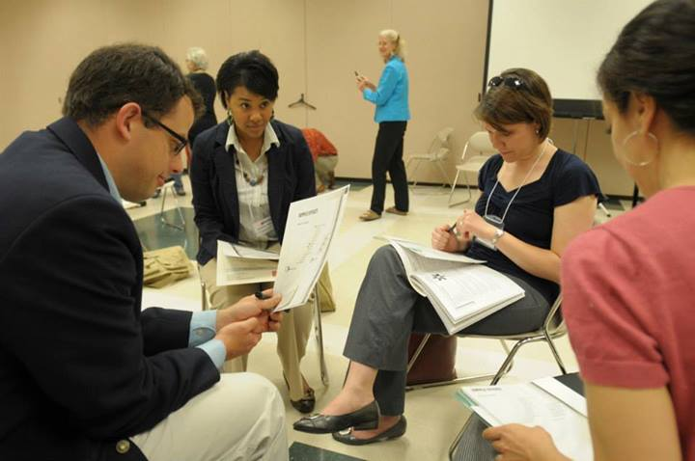

Group Roles & Tasks

When groups work together, it helps if every member takes some responsibility for helping everyone work well together. If each member of a group rotates through all the roles on a regular basis, then everyone can practice the skills of group communication. Here are some roles that can be rotated among group members:

Role Name What This Person Does_____________________________
Facilitator Makes sure everyone gets heard; Asks quiet ones to contribute
their thoughts on the topic. Summarizes discussion and suggests
action based on the discussion.
Focus-Keeper Helps the group stay on task; can interrupt when the group goes on a tangent.
Note-Taker Takes notes and reports.
Empath Pays attention to feelings; can interrupt the work to check in with
someone who is having strong feelings.
Director Runs rehearsals, gives directions, helps everyone look
good and be heard. Director listens to suggestions from others, but has final say-so. Everybody else does what director says.
Process Observer Takes notes and reports on behaviors that help the group
collaborate creatively.

Critical Response Process
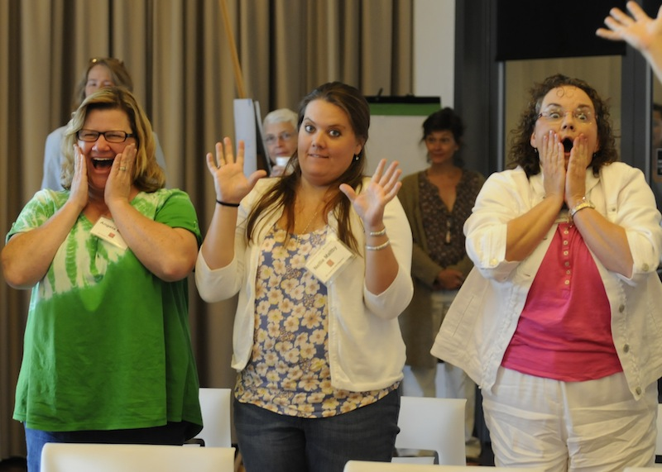
When asking for feedback on presentations, I only entertain positive language. I want to know what will improve what we just saw—anybody can point out what is wrong with a thing, but I want us to be the geniuses who can figure out the solutions to problems raised by the presentations—that is creative thinking. (Thanks to Dale Carnegie.)

When working with people new to collaborative creative process, my critical response process is to ask:
What happened?
What did you see?
What did you hear?
What did you experience?
What did you feel? When?
What did you think? (Not if you thought it was good—just what ideas came into your head while you watched.)

The critical response to rounds is designed to find the good stuff and make connections to where it might be headed:
What did you see/hear/experience that you liked? Why?
What did it remind you of?
What did it make you think of?
Where could it go?
What does it relate to?

Some useful questions to elicit positive feedback:
- What worked?
- What was effective?
- When and why were you moved?
- What did you learn or discover?
- What questions would you like to ask?
- Do you have any suggestions that improve it?

One-Element-at-a-Time Critical Response: (I learned this from C.W. Metcalf.)
You choose what element of your art form you are working on. (E.g.: timing, vocal clarity, editing out redundancies, clarifying status relationships…)
You rehearse or write focusing on that element.
You critique that element, only.
You write down what you decide about that element that you want to keep.

Liz Lerman’s Critical Response Process
For a deeper discussion of a work-in-process, see http://www.lizlerman.com/crpLL.html

Affirmations

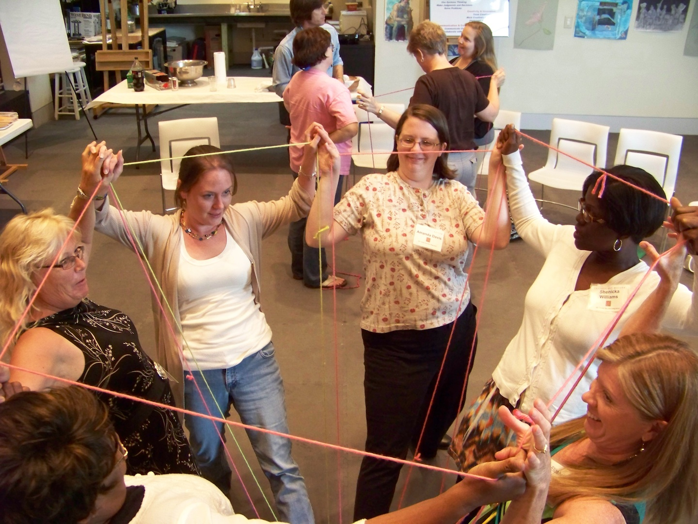
An affirmation is a short statement of something you want to acknowledge, remember, or value that someone else said or did. You give an affirmation to a particular person or a group. The more specific you can be, the better. Giving affirmations can help people learn their strengths, gain confidence in their abilities, build trust, and get them in the habit of supporting each other’s efforts.

Ask participants what they saw or heard somebody else say or do that they would like to acknowledge. Encourage them to look at the person they are acknowledging and speak to him or her.

- The Emerging Goddess, The Creative Process in Art, Science & Other Fields, Albert Rothenberg, Chicago, U. of Chicago Press, 1979, p. 6
- Synectics The Development of Creative Capacity, William J.J. Gordon, New York, Collier Books, 1961, p. 34.

