Southeast Center for Arts Integration
2310 Stansbury Road
Chapel Hill, NC 27516
919-942-4264
www.CenterforArtsintegration.org

How do I Get My Students
to Collaborate and Discuss Effectively?

Sheila Kerrigan
Jef Lambdin

This Workshop Addresses These Forum Questions:
How should contemporary environments of learning be designed?
How do the ways in which we currently collaborate highlight new needs?
What new elements emerge from collaborating in ways that potentially go against more traditional forms of interacting?

Focus Questions
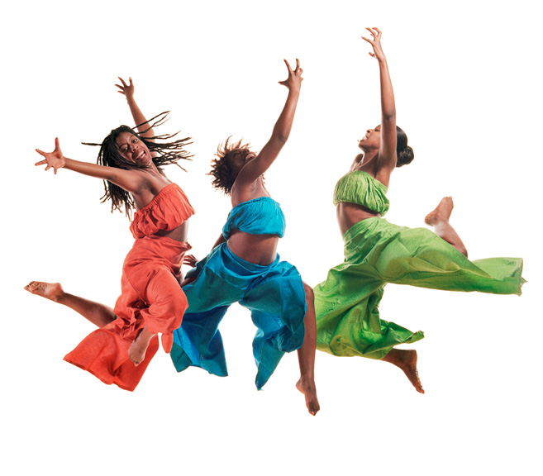

How can we teach and model collaboration for our students? How can we lead our students toward a collaborative classroom?
How can we help our students learn collaboration skills so that they can discuss and create together happily?
How can Theatre Arts boost learning in Health and English Language Arts?
How can we assess curricular learning through Theatre Arts?

AGENDA
(Subject to Change!)
Warming up
Poll for questions and concerns
Check in
Craft agreements
Steps of the group process we will follow
One-Thing-at-a-Time Creative Process
Groups discuss collaboratively
Groups create a presentation collaboratively
Groups rehearse and present
Critical Response Process: Specific questions that refer to the One-Thing-at-a-Time Creative Process; positivity
Process observers report. We scribe behaviors that help a group work together to begin building a norm of collaborative behaviors
Affirmations
Reflection
COMMON CORE GOALS & OBJECTIVES

English Language Arts Standards
3-5.SL.1 Engage effectively in a range of collaborative discussions (one-on-one, in groups, and teacher-led) with diverse partners on grade level topics, texts, and issues, building on others’ ideas and expressing their own clearly. 1.b.Follow rules for discussions and carry out assigned roles.

NC ESSENTIAL STANDARDS GOALS & OBJECTIVES

Health Standards (NC Essential Standards)
3.ICR.1. Understand healthy & effective interpersonal communication & relationships. 3.ICR.1.4 Illustrate how to effectively & respectfully express opinions that differ.
Theatre Arts Standards
3-5.C.1. Use movement, voice, and writing to communicate ideas and feelings.5. C.1.2 Apply appropriate vocal elements of volume, pitch, rate, tone, articulation, and vocal expression in various types of formal and informal presentations (to express character [3rd gr;] to various types of literature & storytelling [4th gr.]).

Creating a Collaborative Classroom

Why is collaboration important?
My art forms—mime and theatre—continue to incorporate ancient practices that communicate through the human body and voice, and continue to touch, move, provoke, and challenge audiences, students, and performers. Theatre is an embodied art form. The process of creating art in theater demands collaborative practices, and teachers need to be able to teach their wired students the basics of collaborative creativity—for both on-line and in-person collaborations. My teaching practice is founded on collaborative creativity, peaceful communication, inclusion, anti-racism work, and community-building. Whether collaborative learning is experienced technologically or not, the basics must be taught.

Collaboration is a key twenty-first century skill. The Common Core curriculum mandates that students engage in collaborative learning across the board—from Mathematics (group problem-solving) to English Language Arts (group discussions). According to Robert Slavin, collaborative learning can narrow the achievement gap between white students and students of color. Students use collaboration skills to socialize and make friends. The workplace requires collaboration. Businesses — Google and Apple, for example — eliminate cubicles to create team workspaces. Creativity thrives on collaboration. Creative thinking is another twenty-first century skill. Finally, if you have the skills for it, collaboration is a fun way to learn!
What is collaboration?
It is a complex set of skills, abilities, and behaviors that can be taught and modeled, including, to mention a few:
- Communication skills: listening, attending to verbal and non-verbal cues and information, giving and receiving positive, useful critiques;
- Cooperation skills: leading and following and switching from leading to following, taking responsibility for group tasks, attending to group process;
- Emotional skills: being aware of one’s own and others’ feelings, expressing feelings appropriately, and showing compassion and empathy;
- Mental skills: focusing on a task until complete, following a conversation, processing it, summarizing it, and taking creative leaps based on it.
And guess what? The performing arts teach these skills!
What prevents teachers from teaching collaboration?
First, a small misunderstanding, “There’s no time to teach it — I’ve got to stick to the curriculum!” Collaborative creative thinking is found all over the Common Core. In the North Carolina Essential Standards collaboration crops up on page after page, in every grade level and many subjects. (E.g.: the fourth grade Science curriculum asks students — not teachers — to describe, discuss, communicate, or explain in twelve of twenty-four objectives. Students must talk to someone to do this.) It’s in the curriculum, and we must teach our students how to do it so that they will succeed.
Second, few teachers study collaboration. How many teachers have taken courses on group dynamics, group communication, or group management?

Teaching and Modeling Collaboration

How can we teach and model collaboration for our students? How can we lead our students toward a collaborative classroom?
Here are three things that I do when I’m working with any group — whether young people or seasoned professionals — that can foster a collaborative environment. They are not difficult, they require no special training, they don’t take much time, and they can be powerful tools for strengthening collaboration skills:
- checking in
- including evaluation of the group process as a part of every collaborative work session
- giving affirmations.

What is checking in?
Checking in means giving everyone a moment to reflect on how he is feeling right now, and then allowing him to name his feeling. If I ask you how you are feeling right now, you might take a breath and make a quick survey of your mental, physical, emotional and/or spiritual state. You might notice a familiar tension in the neck or shoulders. Or perhaps you recall that you have several things on your to-do list and then notice that your heart rate has increased. Or you might remember something that has happened lately that has you feeling proud.
What is the purpose of checking in?
Checking in allows feelings in a room. It acknowledges that we all experience feelings. It lets students practice looking inward (intrapersonal communication) and attending to the complex world of feelings that enriches the human experience. It gives students practice naming feelings—some don’t know the feeling words. It gives everyone practice seeing what feelings look like and hearing what they sound like in other people. It builds trust in a group. It fosters compassion and empathy.
If a student expresses dismay or a strong feeling, that gives me important information, and I know I may want to offer her some extra support or attention or give her a break that day.

PROCESS OBSERVER QUESTIONS

What did you hear someone say that helped the group with the work?

What did you see someone do that helped the group with the work?

What other things helped the group with the work?

How well do you think the group worked together? (Circle one.)

Great Well Fair Not So Well Poor

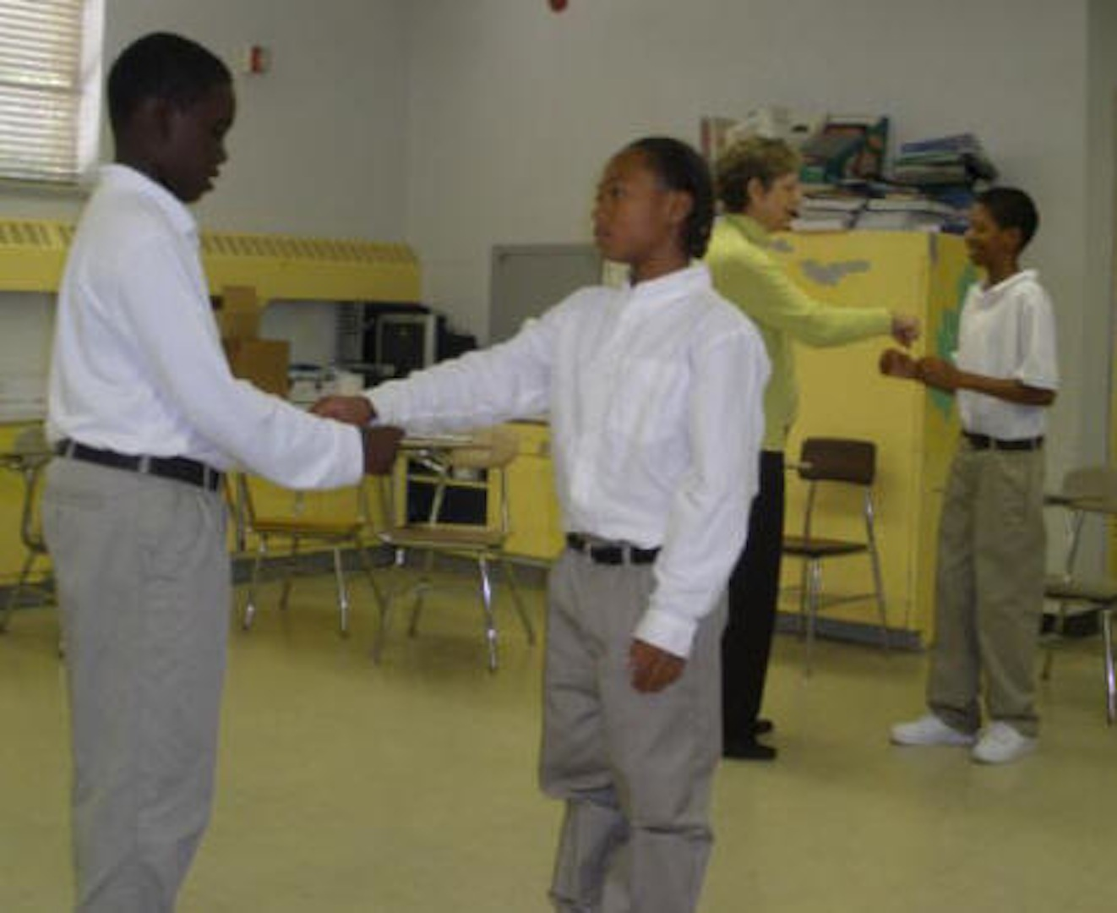
What do you think would have helped the group work better together?

SAMPLE ASSESSMENT QUESTIONS

Yes! Yes. Some. No.
Excellent Good Fair Poor
English Language Arts Speaking & Listening
Did people in the group take turns talking? _______________________________________________
Did they listen to others openly? _________________________________________ _____________
Did they agree on a statement?________________________________________________________
Did they do their group task roles?_____________________________________________________
YOUR ASSESSMENT QUESTIONS

Health
Did the student or group:
Identify a productive behavior in group work?___________________________________________
Identify an unproductive behavior in group work?________________________________________
YOUR ASSESSMENT QUESTIONS

Theatre Arts
Did they use movement, voice & writing to
express thoughts and feelings of characters?_____________________________________________
Did group members use vocal elements:
appropriate volume, rate, articulation?__________________________________________________
YOUR ASSESSMENT QUESTIONS

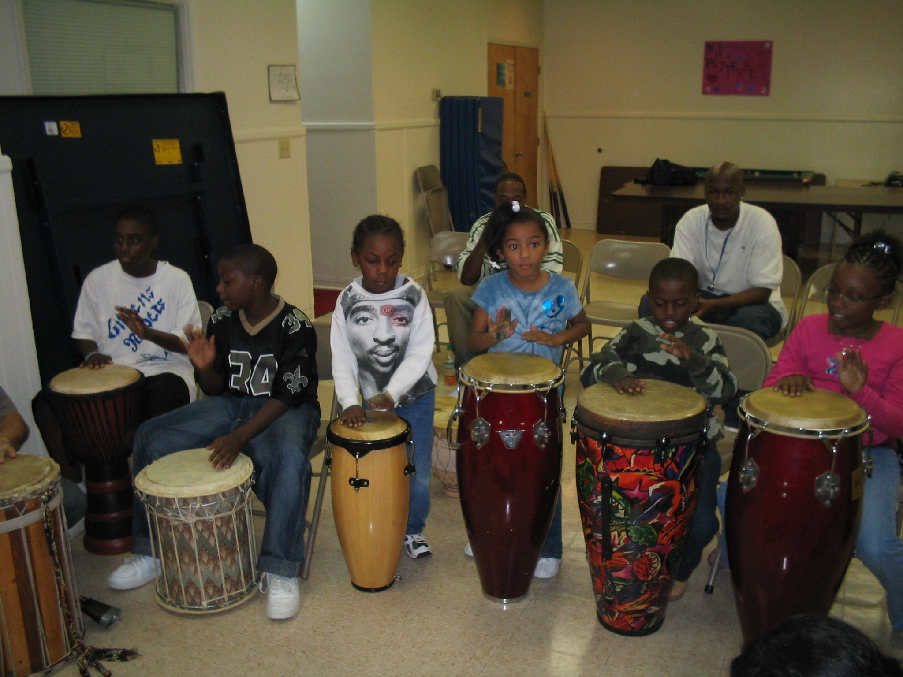

Workshop Evaluation

What questions do you have?

What have you learned about your own collaborations?

What did you notice about other people’s collaborations?

How do you intend to use what you’ve learned?

What would have made this workshop more useful to you?

What about this workshop was useful to you?

Robert E. Slavin, “Cooperative Learning,” American Educational Research Association’s Review of Educational Research

